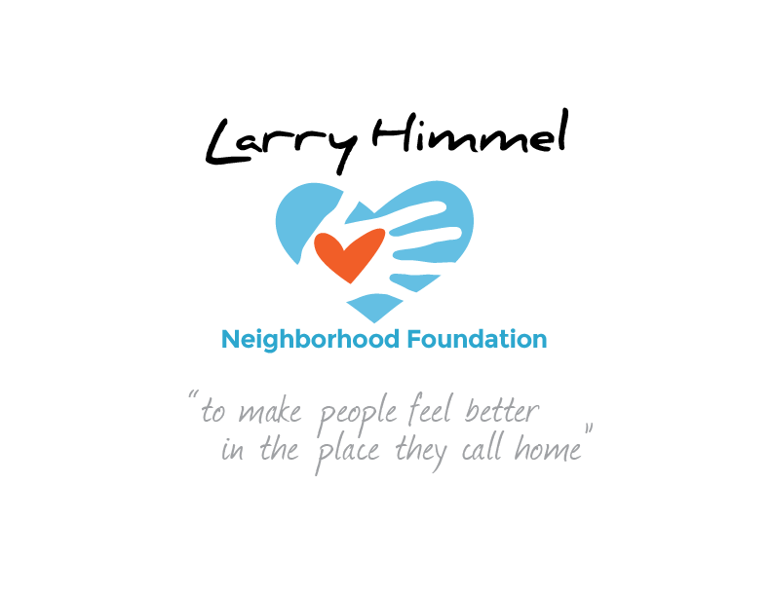

Larry Himmel Neighborhood Foundation
Board of Directors Meeting
May 24, 2016 6:00-7:10pm
Meeting location: KFMB Stations, 7677 Engineer Rd., San Diego, CA 92111

Board members attending:
Dave Sniff (Chairman)
Miles Himmel (Treasurer)
Roy Robertson (Secretary)
Bruce Patch
Pat Elwood
Tom Zizzi

Board members not in attendance:
Jim Holtzman

Meeting minutes recorded by Roy Robertson
This was the initial meeting of the board, so no prior meeting minutes were reviewed

Summary of board meeting:
- Call to order/ roll call
- Introductions of board members
- Update on status of establishing 501( c ) ( 3 ) – application received by the IRS
- Review of expenses and fees paid to Biz Central for establishment of the foundation, state of California filing fee, website development -- allocated from GoFundMe contributions to the foundation (Miles Himmel)
- Financial report on foundation’s current financial resources (Miles Himmel)
- Discussion of the need to review foundations by-laws (to be provided by Miles Himmel)
- Discussion on formalizing foundation’s mission statement
- Clarification that the foundation acts as a separate entity from the KFMB Stations and needs to develop autonomously, with potential support from the stations as a media partner
- Preliminary discussion on foundation’s objectives and fundraising recipients
- Update on creating the foundation’s website and discussion about its content
- Discussion about contacting an attorney to attend future board meetings in a consultancy/ advisory capacity
- Discussion of use of social media and website as outreach to potential beneficiaries
- Discussion of possible events to be staged as fundraisers (concerts, events)
- Discussion of board members roles in creating video content and social media to promote the foundation
- Targeting June 13, 2016 as a possible date for next phase of social media promotion
- Projection of future board meeting schedule – once per month or as needed

No official resolutions or actions were voted upon by the board at this meeting

Action steps requested of board members prior to next meeting:
- Determine date for next meeting
- Review foundation’s by-laws
- Formalize foundation’s mission statement
- Contact attorney as possible consultant/ advisor
- Continue development of website and marketing materials

The meeting was adjourned by the Chairman at 7:10pm

