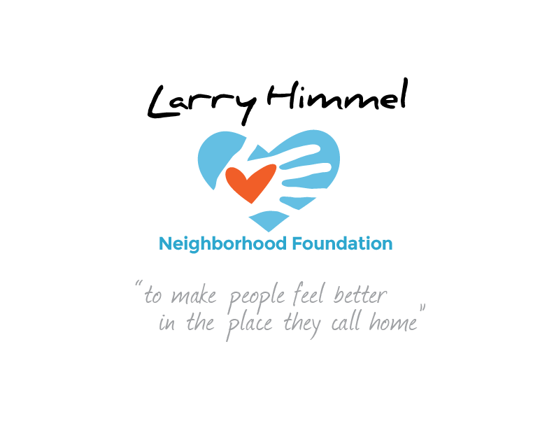

Larry Himmel Neighborhood Foundation
Board of Directors Meeting
January 17, 2017 6:08-7:12pm
Meeting location: KFMB Stations, 7677 Engineer Rd., San Diego, CA 92111

Board members attending:

Dave Sniff (Chairman)
Miles Himmel (Treasurer)
Roy Robertson (Secretary)
Bruce Patch
Tom Zizzi
Courtney Cocoris
Tracy Weaver
Sarai DeJesus

Board members not in attendance:
Pat Elwood

Meeting minutes recorded by Roy Robertson

Summary of board meeting:
- Call to order/ roll call
- Review and acceptance of the minutes from the board meeting on 12/6/16
- Review of December 2016 Foundation projects: Highland Ranch Elementary School, Interfaith Community Center, Sunday School SeaWorld visit
- Recap of media exposure through Union/ Tribune and KFMB-TV
- Review of 2016 contributions to the Foundation and current assets
- Discussion about building and managing database and possible use of CRM
- Discussion of KFMB Stations’ support of web development/ management
- Vote to approve Hal Clement as Foundation board member (unanimously approved)
- Discussion of potential sponsorship from clients – Marrokal, ASI Hastings
- Discussion of promotional opportunities through KFMB Radio/ streaming inventory; possible pre-roll
- Review of potential upcoming stories: Ronda Rockwell wedding, Adaptive Sports & Recreation, Calavera Hills 6th grade outdoor education trip, Riley Special Day School, Valentine’s Day dance school, possible Belly Up Tavern concert for Fall 2017, 2nd annual Back to School haircut event

Action steps requested of board members prior to next meeting:
- Need to discuss accessing KFMB database and web management with Mitch Gruber (Himmel)
- Need to create :60/ :30/ :15 radio spots (Robertson)
- Need to follow up with potential sponsors: Marrokal, ASI (Robertson)
- Need to contact KFMB sales reps re: cause marketing initiatives (Sniff)
- Need to discuss possible CRM acquisition (Robertson)
- Meeting with Dan Shea regarding sponsorship solicitation event (Himmel)

The meeting was adjourned by the Chairman at 7:12pm
##

