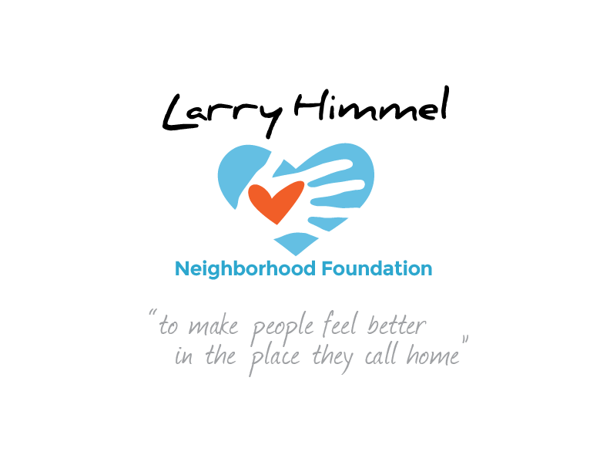

Larry Himmel Neighborhood Foundation
Board of Directors Meeting
December 6, 2016 6:05-7:35pm
Meeting location: KFMB Stations, 7677 Engineer Rd., San Diego, CA 92111

Board members attending:

Miles Himmel (Treasurer/ chaired meeting)
Roy Robertson (Secretary)
Bruce Patch
Tom Zizzi
Courtney Cocoris
Tracy Weaver

Board members not in attendance:
Pat Elwood
Dave Sniff (Chairman)

Meeting minutes recorded by Roy Robertson

Summary of board meeting:
- Call to order/ roll call
- Review and acceptance of the minutes from the board meeting on 10/11/16
- Introduction of Sarai de Jesus
- Update on outreach to Dan Shea and discussion of fundraising event hosted by Donovan’s
- Review of completed outreach letter and discussion of formatting
- Recap of Pancreatic Cancer Action Network Walk/ coverage/ video
- Discussion of setting specific goals in 2017 in order to be more precise in solicitation of sponsorship
- Discussion of media support and challenges at KFMB/ other media outlets
- Discussion of database marketing/ accessing KFMB database to send sponsorship outreach letter
- Discussion of individual charitable gifting prior to 12/31/16
- Planning upcoming Highland Ranch Elementary promotion and logistics
- Planning and discussion on Interfaith Community Services promotion/ execution
- Discussion of upcoming Escondido Sunday school/ Sea World promotion & logistics
- Vote to accept Sarai de Jesus onto Foundation board (unanimously approved)

Action steps requested of board members prior to next meeting:
- Need to be develop specific 2017 objectives and events into 4th quarter
- Board support for upcoming promotions: Highland Ranch Elementary, Interfaith Community Services, Escondido Sunday School
- Need to discuss possibility of accessing KFMB database with Mitch Gruber
- Need to schedule follow up with Dan Shea regarding hosting at alternate locations
- Need top calendar next Foundation meeting
The meeting was adjourned by the Treasurer at 7:22pm
##

