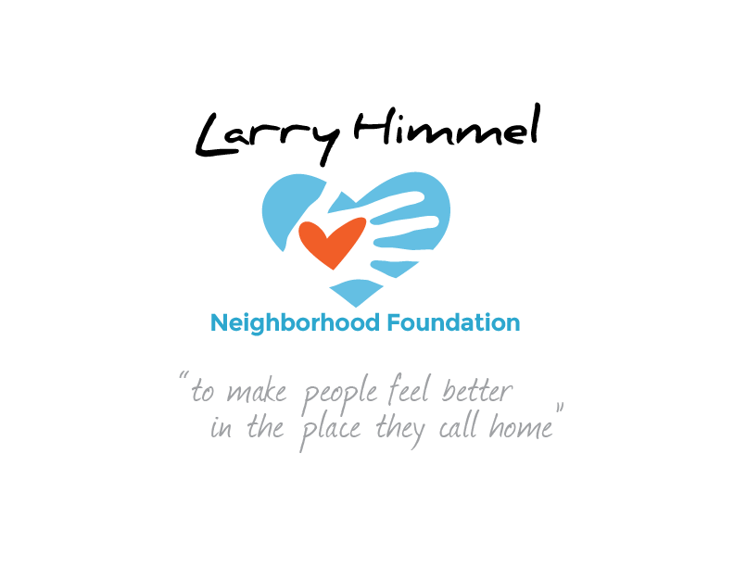

Larry Himmel Neighborhood Foundation
Board of Directors Meeting
October 11, 2016 6:05-7:22pm
Meeting location: KFMB Stations, 7677 Engineer Rd., San Diego, CA 92111

Board members attending:
Dave Sniff (Chairman)
Miles Himmel (Treasurer)
Roy Robertson (Secretary)
Courtney Cocoris
Jim Holtzman
Tom Zizzi
Tracy Weaver

Board members not in attendance:
Pat Elwood
Bruce Patch

Meeting minutes recorded by Roy Robertson
Summary of board meeting:
- Call to order/ roll call
- Review and acceptance of the minutes from the board meeting on 8/31/16
- Recap of purchasing Crawford High School cheerleader outfits / viewing of video shot at event
- Discussion of meeting with Allied Gardens Kiwanis and potential participation in Foundation events
- Discussion of interaction with other community groups: Elks, Optimists, etc.
- Update on SafeLite grant application and possible promotional item to reinforce brand identity
- Recap of Foundation’s presence at Pancreatic Cancer Action Network event
- Discussion of updating Foundation video “melt reel” presentation to include recent events
- Discussion of possible event to be held November 5th – Sister Pee Wee’s
- Discussion of possible event to be held November 5th – Donovan’s/ “Himmel Happy Hour” fundraiser
- Discussion of potential Christmas promotion
- Discussion of “Himmel Homeless Bags” logistics & promotion – Spring 2017?
- Discussion of relationship with DSC as potential 501 ( c ) ( 3 ) partner

Action steps requested of board members prior to next meeting:
- Follow up with SafeLite to review grant submission & discuss potential partnership
- Contact Dan Shea to discuss November 5th reception/ “Himmel Happy Hour”
- Assemble neighborhood photos for 2017 calendar/ discuss potential membership with deliverable (calendar)
- Update production of video melt reel to include Crawford presentation/ PCAN walk
- Continue discussion of potential Christmas events/ 2017 goals
- Next Foundation meeting date TBD

The meeting was adjourned by the Chairman at 7:22pm
##

